**FUNCTIONAL AND TECHNICAL COMBINED DOCUMENTATION**

**Page (44): Monitor Updates for Price (Front End Url:** http://localhost:8100/page44/Page44)

**Functional Picture:**

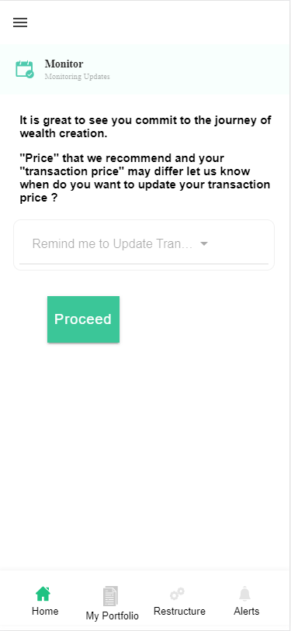

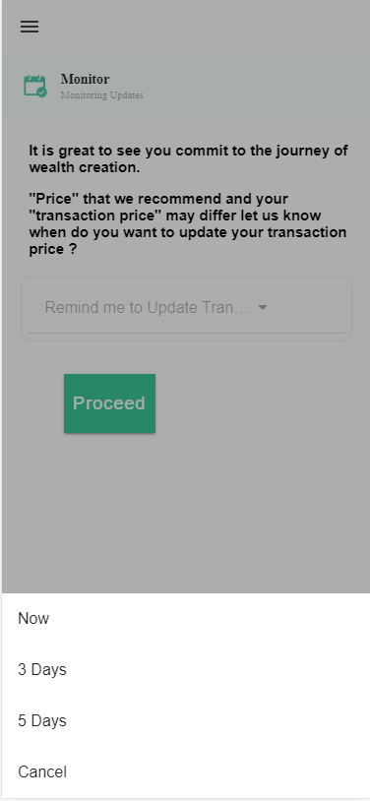

**Technical Explanation (Front End and Back End):**

**In Page40.tsx, we are calling following 1 API:**

1. MonitorTransactionPriceUpdateReminderAPI: see backend python file

**This page is self-explanatory.**

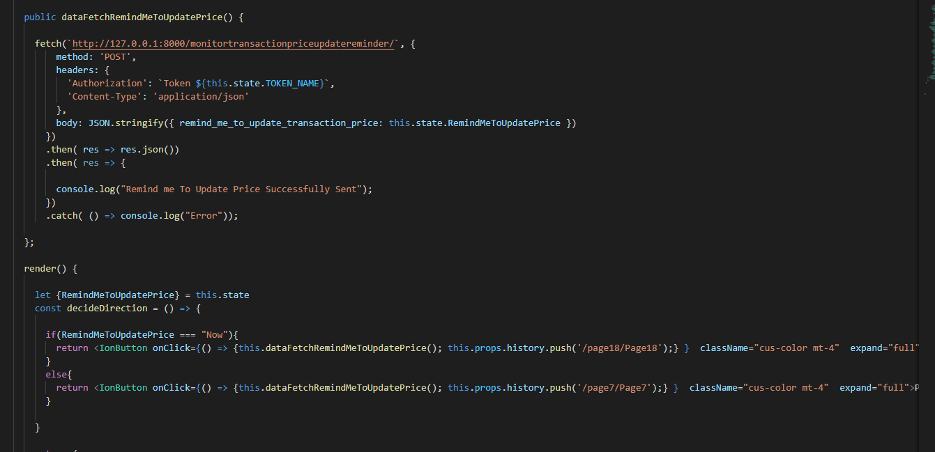

**In this we are calling** MonitorTransactionPriceUpdateReminderAPI

**Where we are saving the reminder in the** MonitorTransactionPriceUpdateReminder model database using MonitorTransactionPriceUpdateReminderSerializer serializer.

Please see the given back end code below.

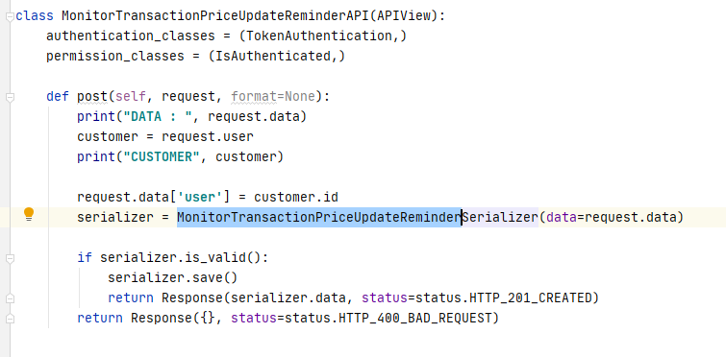

**Please see the code for Serializer and Model Database given below:**

